# header information

"""

author: Maurice Farr

date: 12/9/2024

assignment: SDEV-140 GUI Tkinter App Final Project, Part 2

purpose: This .py file has the rest of the necessary functions to execute the GUI Tkinter App,

"My Glucose Meter Tracker".

"""

#ProjectFunctions.py

**#Source Code of All files (.py):**

from tkinter import*

from tkinter import Message

import time

import pandas as pd

#Define confirmation message for the buttons (create_account_button and login_button)

cnca_message1 = "ERROR: Please fill out the required information to complete this process"

cnca_message2 = " Congrats, you have officially created an account. You can now use your created account to login."

login_message1= "Sorry, you were unable to login."

login_message2 = " Successfully logged in."

#Path for file for to store and retrieve user data

path_for_file = "C:\\Users\\artvs\\OneDrive\\Documents\\SDEV 140 Final Project\\MauriceFarr-DatabaseForFinalProject.csv"

#Define the function to destroy a window

def destroyWindow(widget):

widget.destroy()

#Define the function and add grid layouts for creating a window when clicking the new account button

def new_account_button_clicked():

window_n_a = Toplevel()

window_n_a.geometry("600x500")

window_n_a.config(bg="#ffffff")

#Display the title name of the app on the "new_account_button_clicked" window including adding its grid layouts

title_label2 = Label(window_n_a, text = "My Glucose Meter Tracker", font=("Californian FB", 20, "bold"), fg="#1197e0",bg="#ffffff")

title_label2.grid(row=5, column=5, padx=30, pady=30)

#Create the label and add grid layouts for the email

email_label = Label(window_n_a, text = "Email", font=("Californian FB", 12, "bold"), fg="#1197e0",bg="#ffffff")

email_label.grid(row=20, column=3, padx=20, pady=20)

#Create an entry text field and add grid layouts for the email

entry_email1 = Entry(window_n_a, width=40)

entry_email1.grid(row=20, column=5, padx=30, pady=30)

entry_email1.config(bg="#ffffff")

#Create the label and add grid layouts for the username

username_label = Label(window_n_a, text = "Username", font=("Californian FB", 12, "bold"), fg="#1197e0",bg="#ffffff")

username_label.grid(row=24, column=3, padx=20, pady=20)

#Create an entry text field and add grid layouts for the username

entry_username = Entry(window_n_a, width=40)

entry_username.grid(row=24, column=5, padx=30, pady=30)

entry_username.config(bg="#ffffff")

#Create the label and add grid layouts for the password

password_label = Label(window_n_a, text = "Password", font=("Californian FB", 12, "bold"), fg="#1197e0",bg="#ffffff")

password_label.grid(row=28, column=3, padx=20, pady=20)

#Create an entry text field and add grid layouts for the password

entry_password1 = Entry(window_n_a, width=40)

entry_password1.grid(row=28, column=5, padx=30, pady=30)

entry_password1.config(bg="#ffffff")

#Apply a "create new account" button including adding its grid layouts

create_account_button = Button(window_n_a, text = "Create New Account", font=("Californian FB", 12, "bold"), fg="#1197e0",bg="#ffffff", command= lambda:display_confirmation_message(window_n_a, entry_email1, entry_username, entry_password1, cnca_message1, cnca_message2))

create_account_button.grid(row=31, column=5, columnspan=3, padx=30, pady=20)

#Create a back button and add grid layouts for the "new_account_button_clicked" window

back_button1 = Button(window_n_a, text="Back", font=("Californian FB", 12, "bold"), fg="#1197e0",bg="#ffffff", command=lambda: destroyWindow(window_n_a))

back_button1.grid(row=1, column=0, padx=30, pady=20)

#Define the function to open a new window to display the message that new account has been created including adding grid layouts and the parameters

def display_confirmation_message(window_combine, entry_email1, entry_username, entry_password1, display_message1, display_message2):

email = entry_email1.get()

username = entry_username.get()

password = entry_password1.get()

#Conditional if-else statement to check if there are any entries filled in the entry box for creating new account

if len(email) != 0 and len(username) != 0 and len(password) != 0: #Indication that no entries are filled out in the entry box

window_cnca = Toplevel()

window_cnca.geometry("700x65")

window_cnca.config(bg="#ffffff")

cnca_label = Label(window_cnca, text= display_message2, font=("Californian FB", 12, "bold"), fg="#1197e0",bg="#ffffff")

cnca_label.grid(row=28, column=3, padx=20, pady=20)

window_cnca.after(3000, lambda: destroyWindow(window_cnca)) # Indication that the cnca_message1 will display for 3 seconds before disappearing

window_combine.destroy() # Both windows (window_n_a and window_cnca) will disappear

else:

window_cnca = Toplevel()

window_cnca.geometry("700x65")

window_cnca.config(bg="#ffffff")

cnca_label = Label(window_cnca, text= display_message1, font=("Californian FB", 12, "bold"), fg="#1197e0",bg="#ffffff")

cnca_label.grid(row=28, column=3, padx=20, pady=20)

window_cnca.after(3000, lambda: destroyWindow(window_cnca)) # Indication that the cnca_message2 will display for 3 seconds before disappearing

window_combine.destroy() # Both windows (window_n_a and window_cnca) will disappear

#Define the function to open a new window when clicking the login button including adding its grid layouts

def login_button_clicked():

window_login = Toplevel()

window_login.geometry("700x450")

window_login.config(bg="#ffffff")

#Display the title name of the app on the "login_button_clicked" window including adding its grid layouts

title_label2 = Label(window_login, text = "My Glucose Meter Tracker", font=("Californian FB", 20, "bold"), fg="#1197e0",bg="#ffffff")

title_label2.grid(row=5, column=5, padx=30, pady=30)

#Create the label and add grid layouts for the email

username_email_label = Label(window_login, text = "Username or Email", font=("Californian FB", 12, "bold"), fg="#1197e0",bg="#ffffff")

username_email_label.grid(row=20, column=3, padx=20, pady=20)

#Create the entry text field and add grid layouts for the mail

entry_username_email = Entry(window_login, width=40)

entry_username_email.grid(row=20, column=5, padx=30, pady=30)

entry_username_email.config(bg="#ffffff")

#Create the label and add grid layouts for the password

password_label = Label(window_login, text = "Password", font=("Californian FB", 12, "bold"), fg="#1197e0",bg="#ffffff")

password_label.grid(row=28, column=3, padx=20, pady=20)

#Create the entry text field and add grid layouts for the password

entry_password2 = Entry(window_login, width=40)

entry_password2.grid(row=28, column=5, padx=30, pady=30)

entry_password2.config(bg="#ffffff")

#Create a login button including adding its grid layouts

login_button = Button(window_login, text = "Login", font=("Californian FB", 12, "bold"), fg="#1197e0",bg="#ffffff", command=lambda: login_process(entry_username_email, entry_password2, window_login))

login_button.grid(row=31, column=5, columnspan=3, padx=30, pady=20)

#Create a back button for the "login_button_clicked" window including adding its grid layouts

back_button2 = Button(window_login, text="Back", font=("Californian FB", 12, "bold"), fg="#1197e0", bg="#ffffff", command= lambda: destroyWindow(window_login))

back_button2.grid(row=1, column=0, padx=30, pady=20)

#Define the function for the login process by including parameters (entry box for both username and password, and window_login) and the grid layouts

def login_process(username_entrybox, password_entrybox, window_login):

username= username_entrybox.get()

password= password_entrybox.get()

#Import user data by reading the file using the cvs method

df1 = pd.read_csv ("C:\\Users\\artvs\\OneDrive\\Documents\\SDEV 140 Final Project\\MauriceFarr-DatabaseForFinalProject.csv")

#Identify if a character exist in username by connecting to the database

if '@' in username:

entries = df1[(df1["email"] == username) & (df1["password"] == password)]

else:

entries = df1[(df1["username"]==username) & (df1["password"]==password)]

#Conditional if-else statement to check if whether there are any entries after clicking the login button

if len(entries) == 0: #indication that there are missing or invalid info into entry text field when logging in

window_error1 = Toplevel()

window_error1.geometry("300x65")

window_error1.config(bg="#ffffff")

error1_label = Label(window_error1, text= login_message1, font=("Californian FB", 12, "bold"), fg="#1197e0",bg="#ffffff")

error1_label.grid(row=28, column=3, padx=20, pady=20)

window_error1.after(3000, lambda: destroyWindow(window_error1)) # Indication that the login_message1 will display for 3 seconds before disappearing

window_login.destroy() # Window_login will disappear after failing to login

else:

#Indication that the user was able to log in

window_login_succces = Toplevel()

window_login_succces.geometry("220x65")

window_login_succces.config(bg="#ffffff")

window_login_succces_label = Label(window_login_succces, text=login_message2, font=("Californian FB", 12, "bold"), fg="#1197e0",bg="#ffffff")

window_login_succces_label.grid(row=28, column=3, padx=20, pady=20)

window_login_succces.after(3000, lambda: destroyWindow(window_login_succces)) # Indication that the login_message2 will display for 3 seconds before disappearing

window_login.destroy() # Window_login will disappear after logging

display_blood_glucose_level() #Transition to open a new window,"window_blood_glucose_level", after logging in

#Define the function to create window for the blood glucose level including adding grid layouts

def display_blood_glucose_level():

window_blood_glucose_level = Toplevel()

window_blood_glucose_level.geometry("600x250")

window_blood_glucose_level.config(bg="#ffffff")

#Display the title label and add grid layouts for the "blood_glucose_level" window

title_label3 = Label(window_blood_glucose_level, text = "Please enter your blood glucose level", font=("Californian FB", 18, "bold"), fg="#1197e0",bg="#ffffff")

title_label3.grid(row=5, column=2, padx=(140,10), pady=30)

#Create entry text field and add grid layouts for blood glucose level

entry_blood_glucose_level = Entry(window_blood_glucose_level, width=20)

entry_blood_glucose_level.grid(row=15, column=2, padx=(140,20), pady=20)

entry_blood_glucose_level.config(bg="#ffffff")

#Display the title label of the measurement units, milligrams (mg) per decilitre (dL), including adding its grid layouts

title_label4 = Label(window_blood_glucose_level, text="mg/dL",font=("Californian FB", 12, "bold"), fg="#1197e0", bg="#ffffff")

title_label4.grid(row=15, column=2, padx=(350,20), pady=20)

#Apply a "submit" button for the blood glucose level including adding its grid layouts

submit_button = Button(window_blood_glucose_level, text="Submit", font=("Californian FB", 12, "bold"), fg="#1197e0",bg="#ffffff", command= lambda: submit_blood_glucose (window_blood_glucose_level,entry_blood_glucose_level.get()))

submit_button.grid(row=20, column=2, columnspan=1, padx=(140,10), pady=20)

#Define the function for the results when the user submit their blood glucose level including adding its parameters (window_combine, user_glucose) and grid layouts

def submit_blood_glucose(window_combine, user_glucose):

if len(user_glucose) == 0: #Check to see if there are any empty entries for entering blood glucose level

window_error2 = Toplevel()

window_error2.geometry("490x60")

window_error2.config(bg="#ffffff")

error2_label = Label(window_error2, text=" ERROR: Please enter your blood glucose level!",font=("Californian FB", 12, "bold"), fg="#1197e0", bg="#ffffff")

error2_label.grid(row=28, column=3, padx=20, pady=20)

window_error2.after(3000, lambda: destroyWindow(window_error2)) #The "error_2" message will display for 3 seconds before disappearing

else:

user_glucose = float(user_glucose) #Indication we can now enter a number

if user_glucose < 0: #Determine if blood glucose level is less than zero

window_error3 = Toplevel()

window_error3.geometry("455x60")

window_error3.config(bg="#ffffff")

error3_label = Label(window_error3, text=" ERROR: You cannot have a negative value!", font=("Californian FB", 12, "bold"), fg="#1197e0", bg="#ffffff")

error3_label.grid(row=28, column=3, padx=20, pady=20)

window_error3.after(3000, lambda: destroyWindow(window_error3)) #The "error_3" message will display for 3 seconds before disappearing

elif user_glucose != int(user_glucose): #Determine if blood glucose level is a decimal number

window_error4 = Toplevel()

window_error4.geometry("455x60")

window_error4.config(bg="#ffffff")

error4_label = Label(window_error4, text=" ERROR: You cannot have a decimal value!", font=("Californian FB", 12, "bold"), fg="#1197e0", bg="#ffffff")

error4_label.grid(row=28, column=3, padx=20, pady=20)

window_error4.after(3000, lambda: destroyWindow(window_error4)) #The "error_4" message will display for 3 seconds before disappearing

else:

if user_glucose >150: #The range for target numbers for high blood glucose levels

window_high = Toplevel()

window_high.geometry("250x60")

window_high.config(bg="#ffffff")

high_label = Label(window_high, text=" Blood glucose is TOO HIGH.", font=("Californian FB", 12, "bold"), fg="#1197e0",bg="#ffffff")

high_label.grid(row=28, column=3, padx=20, pady=20)

window_high.after(3000, lambda: destroyWindow(window_high)) #The high message will display for 3 seconds before disappearing

window_combine.destroy() #Both windows (window_high and window_blood_glucose_level) will disappear

elif user_glucose >= 100 and user_glucose <= 150: #The range for target numbers for normal blood glucose levels

window_normal = Toplevel()

window_normal.geometry("250x60")

window_normal.config(bg="#ffffff")

normal_label = Label(window_normal, text=" Blood glucose is NORMAL.", font=("Californian FB", 12, "bold"),fg="#1197e0", bg="#ffffff")

normal_label.grid(row=28, column=3, padx=20, pady=20)

window_normal.after(3000, lambda: destroyWindow(window_normal)) #The "normal" message will display for 3 seconds before disappearing

window_combine.destroy() #Both windows (window_normal and window_blood_glucose_level) will

elif user_glucose >= 71 and user_glucose <= 99: #The range target numbers for borderline low blood glucose levels

window_borderline = Toplevel()

window_borderline.geometry("330x60")

window_borderline.config(bg="#ffffff")

borderline_label = Label(window_borderline, text=" Blood glucose is BORDERLINE LOW.", font=("Californian FB", 12, "bold"),fg="#1197e0", bg="#ffffff")

borderline_label.grid(row=28, column=3, padx=20, pady=20)

window_borderline.after(3000, lambda: destroyWindow(window_borderline)) #The "borderline low" message will display for 3 seconds before disappearing

window_combine.destroy() #Both windows (window_borderline and window_blood_glucose_level) will disappear

elif user_glucose <= 70: #The range for target numbers for low blood glucose levels

window_low = Toplevel()

window_low.geometry("230x60")

window_low.config(bg="#ffffff")

low_label = Label(window_low, text=" Blood glucose is LOW.", font=("Californian FB", 12, "bold"), fg="#1197e0", bg="#ffffff")

low_label.grid(row=28, column=3, padx=20, pady=20)

window_low.after(3000, lambda: destroyWindow(window_low)) #The "low" message display for 3 seconds before disappearing

window_combine.destroy() #Both windows (window_low and window_blood_glucose_level) will disappear

#Define the function for clicking the reset new password button including adding grid layouts

def forgot_reset_password_button_clicked():

window_frp = Toplevel()

window_frp.geometry("750x520")

window_frp.config(bg="#ffffff")

#Display the title name of the app on the "forgot_reset_password_clicked" window including adding its grid layouts

title_label2 = Label(window_frp, text = "My Glucose Meter Tracker", font=("Californian FB", 20, "bold"), fg="#1197e0",bg="#ffffff")

title_label2.grid(row=5, column=2, columnspan=1, padx=30, pady=40)

#Create the label and add grid layouts for the email

email_label2 = Label(window_frp, text="Email", font=("Californian FB", 12, "bold"), fg="#1197e0", bg="#ffffff")

email_label2.grid(row=20, column=1, columnspan=1, padx=20, pady=20)

#Create the entry text field and add grid layouts for the email

entry_email2= Entry(window_frp, width=40)

entry_email2.grid(row=20, column=2, padx=30, pady=30)

entry_email2.config(bg="#ffffff")

#Create the label and add grid layouts to reset the password

reset_password_label = Label(window_frp, text = "Type New Password", font=("Californian FB", 12, "bold"), fg="#1197e0",bg="#ffffff")

reset_password_label.grid(row=23, column=1, columnspan=1, padx=20, pady=20)

#Create the entry text field and add grid layouts to type the new password

entry_password3=Entry(window_frp, width=40)

entry_password3.grid(row=23, column=2, padx=30, pady=30)

entry_password3.config(bg="#ffffff")

#Create the label and add grid layouts to confirm new the password

confirm_new_password_label = Label(window_frp, text = "Retype New Password", font=("Californian FB", 12, "bold"), fg="#1197e0",bg="#ffffff")

confirm_new_password_label.grid(row=26, column=1, columnspan=1, padx=20, pady=20)

#Create the entry text field and add grid layouts to confirm new password including

entry_confirm_new_password = Entry(window_frp, width=40)

entry_confirm_new_password.grid(row=26, column=2, padx=30, pady=30)

entry_confirm_new_password.config(bg="#ffffff")

#Apply a "create new password" button including adding its grid layouts

create_new_password_button = Button(window_frp, text = "Create New Password", font=("Californian FB", 12, "bold"), fg="#1197e0",bg="#ffffff", command= lambda: update_password(window_frp, path_for_file, entry_email2, entry_password3,entry_confirm_new_password))

create_new_password_button.grid(row=27, column=2, columnspan=5, padx=30, pady=20)

#Create a back button for the "forgot_reset_password_button_clicked" window including adding its grid layouts

back_button3 = Button(window_frp, text="Back", font=("Californian FB", 12, "bold"), fg="#1197e0", bg="#ffffff",command=lambda: destroyWindow(window_frp))

back_button3.grid(row=1, column=0, padx=30, pady=20)

#Define the function to reset new password using parameters (email, password, and retype password) for the entry box by connecting to the database

def update_password(window_combine, path_for_file, email_entrybox, new_password_entrybox, retype_new_password_entrybox):

email = email_entrybox.get() #Get the user to enter their email in the entrybox

new_password = new_password_entrybox.get() ##Get the user to enter new password in the entrybox

retype_new_password = retype_new_password_entrybox.get() #Get the user to reenter their new password in the entrybox for confirmation

#Import user data by reading the file using the cvs method

df1 = pd.read_csv("C:\\Users\\artvs\\OneDrive\\Documents\\SDEV 140 Final Project\\MauriceFarr-DatabaseForFinalProject.csv")

#Conditional if-else statements for resetting new password

if (len (new_password) != 0 #Check if there is an entry to type new password

and len (retype_new_password) != 0 #Check if there is an entry to retype new password for confirmation

and new_password == retype_new_password): #Check if the password that is typed in both entrybox (the new_password and retype_new_password) matches with each other

#Identify if a character exist in email by connecting to the database

df1.loc[df1["email"] == email, 'password'] = retype_new_password

df1.to_csv(path_for_file, index=False)

#Create a window and adding grid layouts to display the message that the new password has been created

window_npw = Toplevel()

window_npw.geometry("600x65")

window_npw.config(bg="#ffffff")

pw_label = Label(window_npw,text=" New password has been reset. You can now use your new password to login.",font=("Californian FB", 12, "bold"), fg="#1197e0", bg="#ffffff")

pw_label.grid(row=28, column=3, padx=20, pady=20)

window_npw.after(3000, lambda: destroyWindow(window_npw)) #The new password confirmation will display for 3 seconds before disappearing

window_combine.destroy() #Both windows (window_frp and window_npw) will disappear

else: #Create a window and adding grid layouts to display an error message while creating new password

window_npw = Toplevel()

window_npw.geometry("330x65")

window_npw.config(bg="#ffffff")

pw_label = Label(window_npw,text="ERROR: Please fill out or correct any entries!",font=("Californian FB", 12, "bold"), fg="#1197e0", bg="#ffffff")

pw_label.grid(row=28, column=3, padx=20, pady=20)

window_npw.after(3000, lambda: destroyWindow(window_npw)) #The error message will display for 3 seconds before disappearing

window_combine.destroy() #Both windows (window_frp and window_npw) will disappear

**Screenshot of Source Code of All Files #1:**

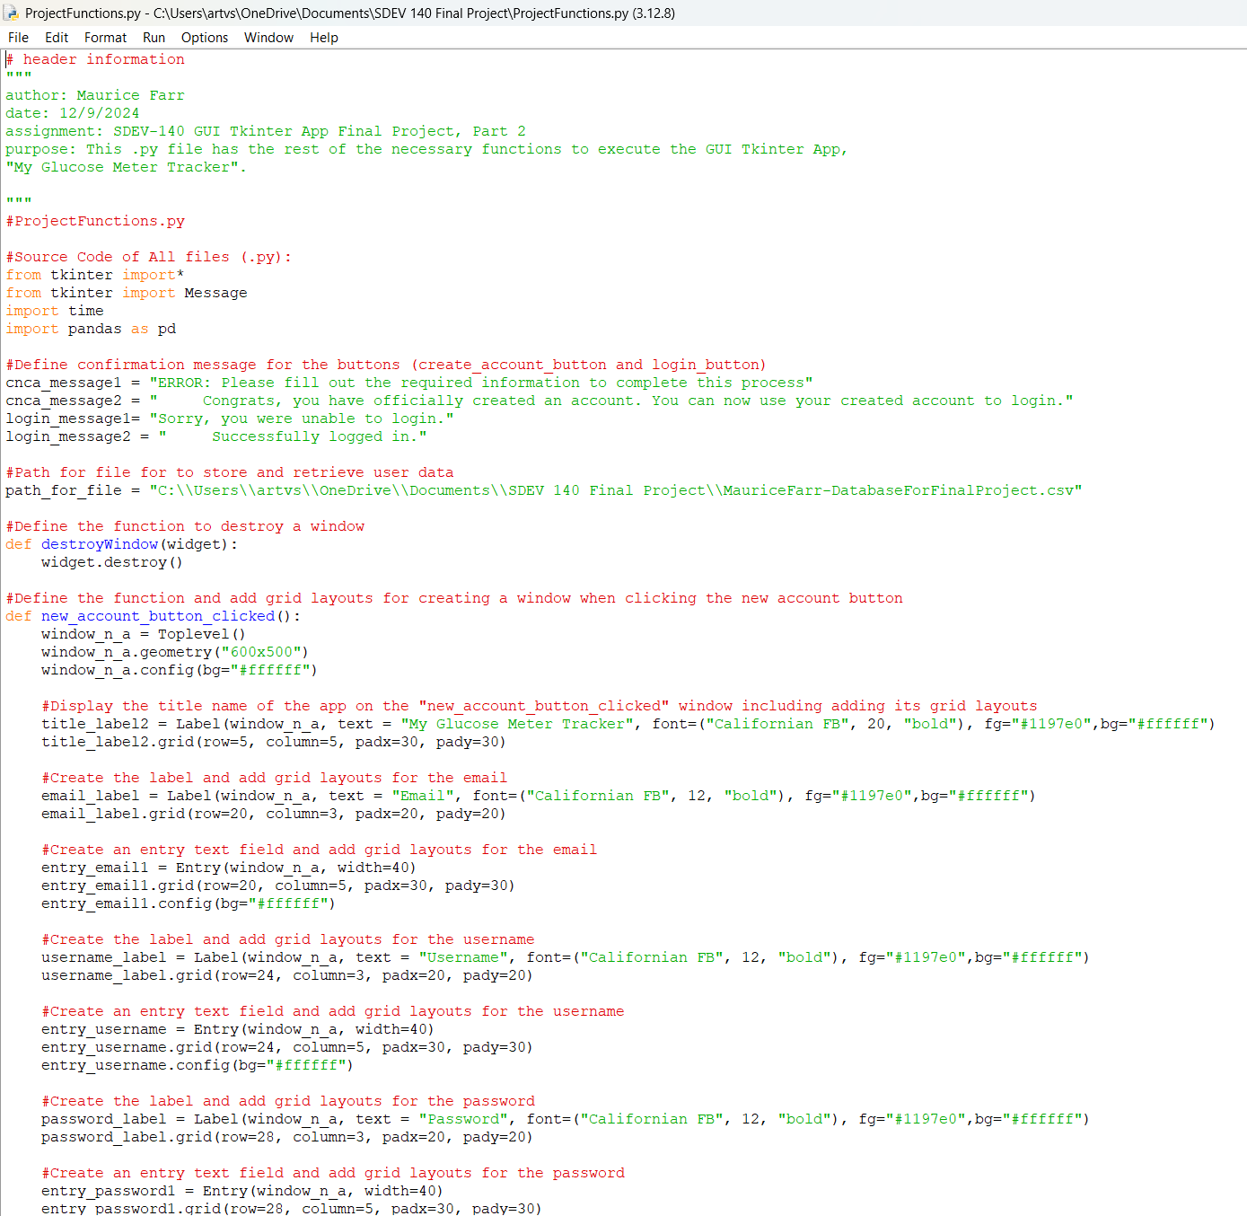

**Screenshot of Source Code of All Files #2:**

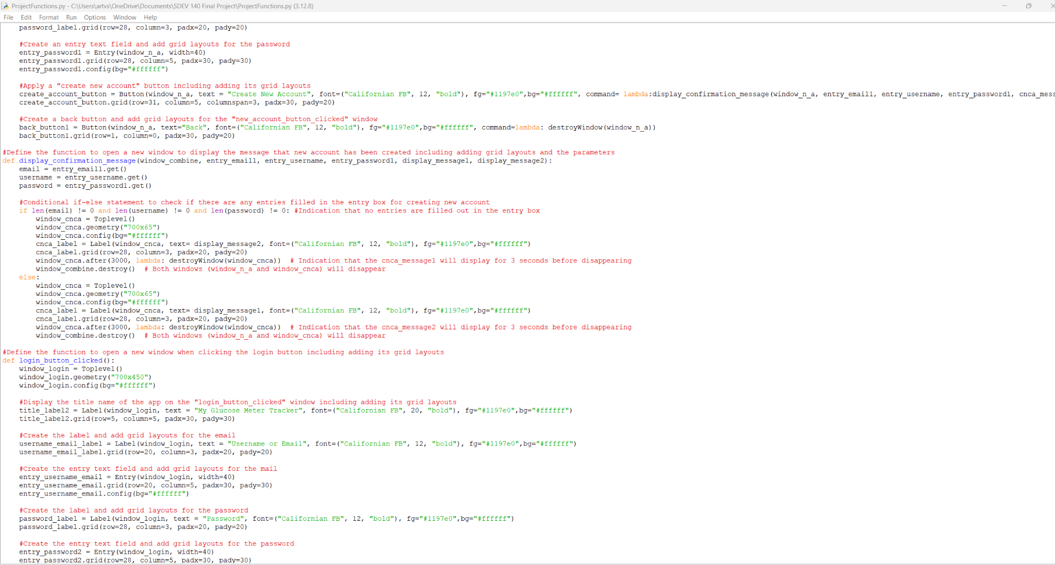

**Screenshot of Source Code of All Files #3:**

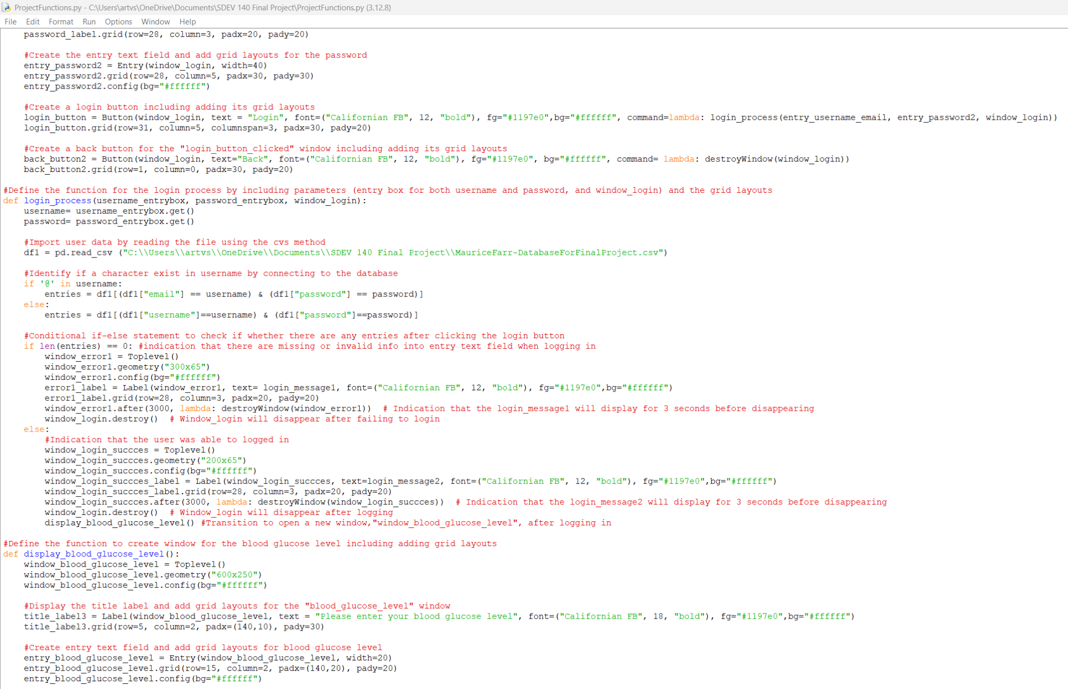

**Screenshot of Source Code of All Files #4:**

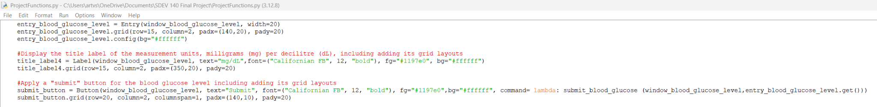

**Screenshot of Source Code of All Files #5:**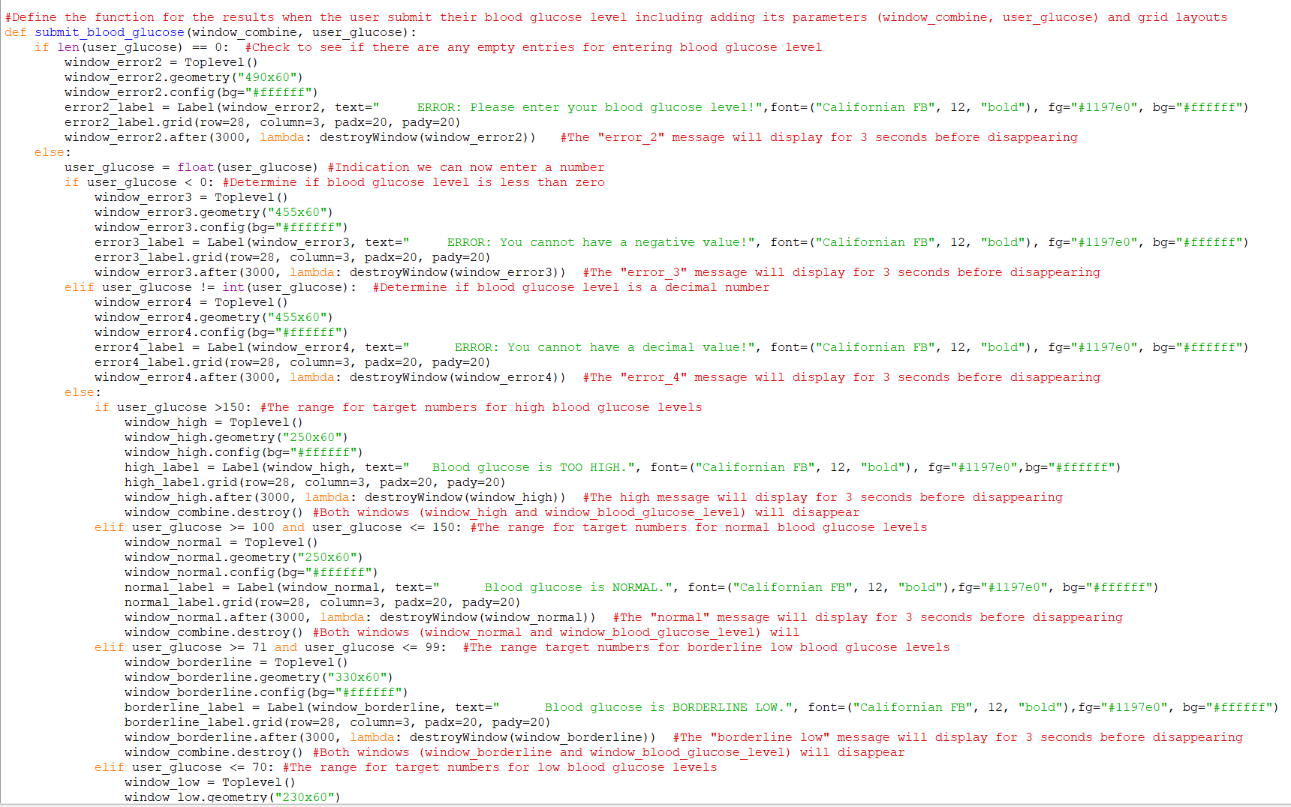

**Screenshot of Source Code of All Files #6:**

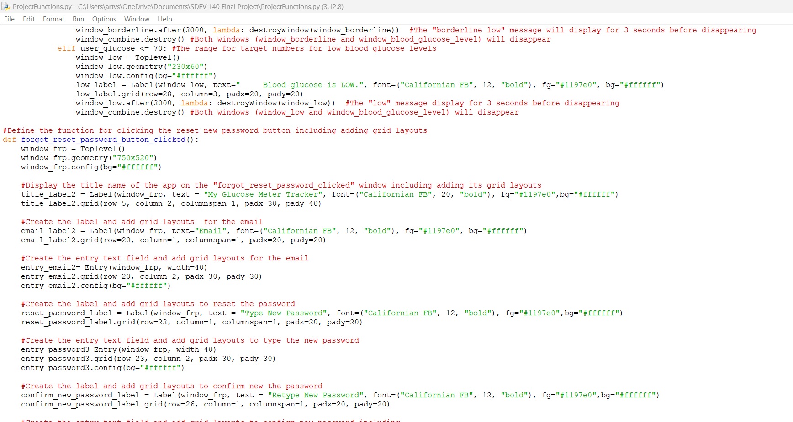

**Screenshot of Source Code of All Files #7:**

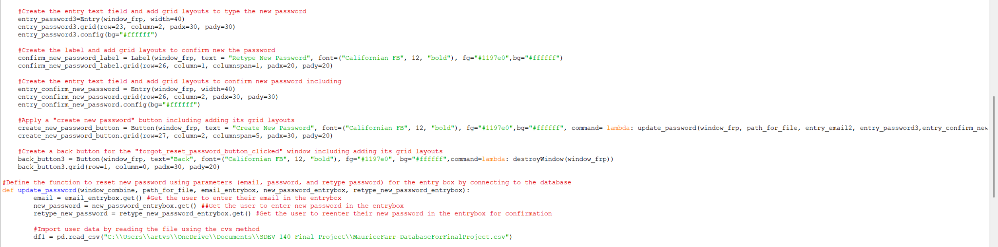

**Screenshot of Source Code of All Files #8:**

